## **Project 01**

### **Objectives:**

* Create and manage Docker volumes for data persistence.
* Set up a Docker network for container communication.
* Use Docker Compose to manage multi-container applications.
* View and manage Docker logs.
* Deploy the application using Docker Swarm.

### **Project Outline:**

1. **Create Docker Volumes**
2. **Create a Docker Network**
3. **Write a Docker Compose File**
4. **Deploy the Application with Docker Compose**
5. **Manage Docker Logs**
6. **Deploy the Application Using Docker Swarm**

### **Step-by-Step Guide**

#### **1. Create Docker Volumes**

Docker volumes are used to persist data generated by and used by Docker containers.

docker volume create wordpress_data

docker volume create mysql_data

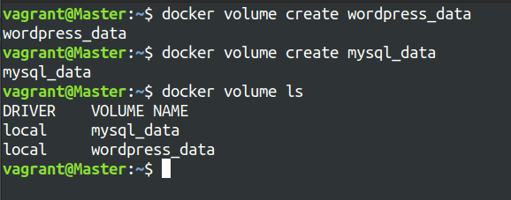

#### **2. Create a Docker Network**

Create a custom network for the containers to communicate.

docker network create wordpress_network

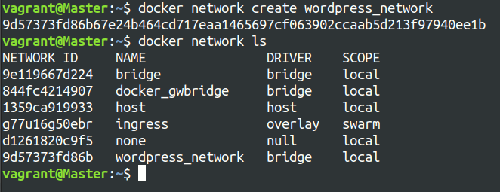

#### **3. Write a Docker Compose File**

Create a docker-compose.yml file to define and manage the services.

version: '3.3'

services:

db:

image: mysql:5.7

volumes:

- mysql_data:/var/lib/mysql

networks:

- wordpress_network

environment:

MYSQL_ROOT_PASSWORD: example

MYSQL_DATABASE: wordpress

MYSQL_USER: wordpress

MYSQL_PASSWORD: wordpress

wordpress:

image: wordpress:latest

volumes:

- wordpress_data:/var/www/html

networks:

- wordpress_network

ports:

- "8000:80"

environment:

WORDPRESS_DB_HOST: db:3306

WORDPRESS_DB_USER: wordpress

WORDPRESS_DB_PASSWORD: wordpress

WORDPRESS_DB_NAME: wordpress

volumes:

mysql_data:

wordpress_data:

networks:

wordpress_network:

#### **4. Deploy the Application with Docker Compose**

Run the following command to start the services defined in the docker-compose.yml file.

docker-compose up -d

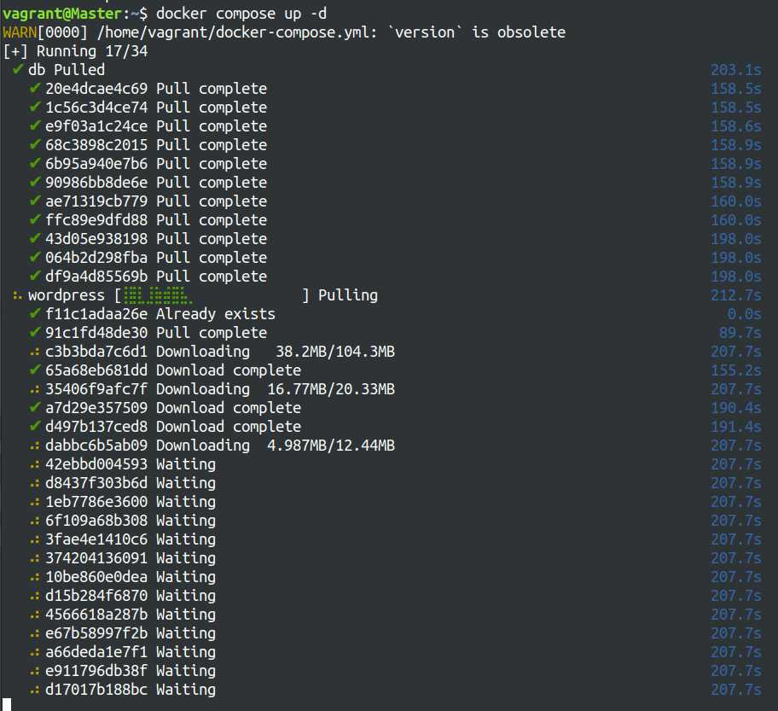

* Verify that the containers are running.

docker-compose ps

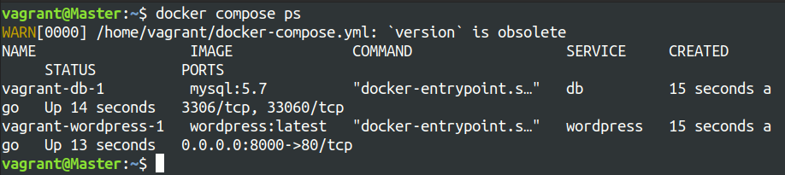

* Access the WordPress setup by navigating to http://localhost:8000.

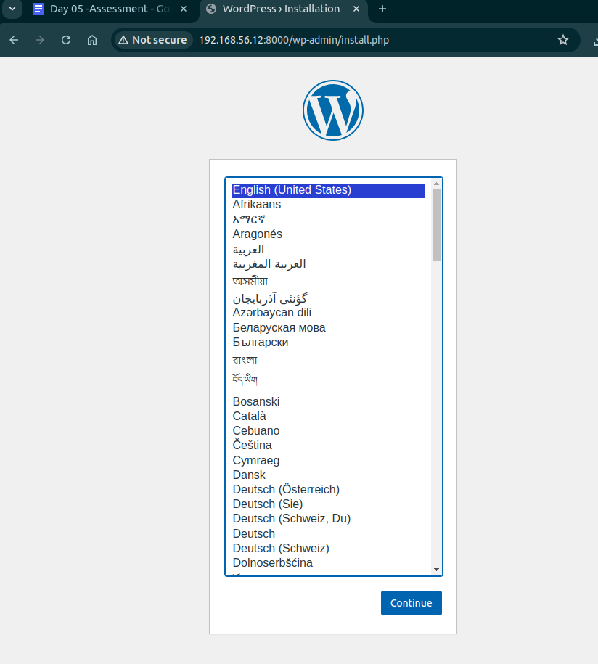

#### **5. Manage Docker Logs**

* View logs for a specific service.

docker-compose logs wordpress

* Follow logs for real-time updates.

docker-compose logs -f wordpress

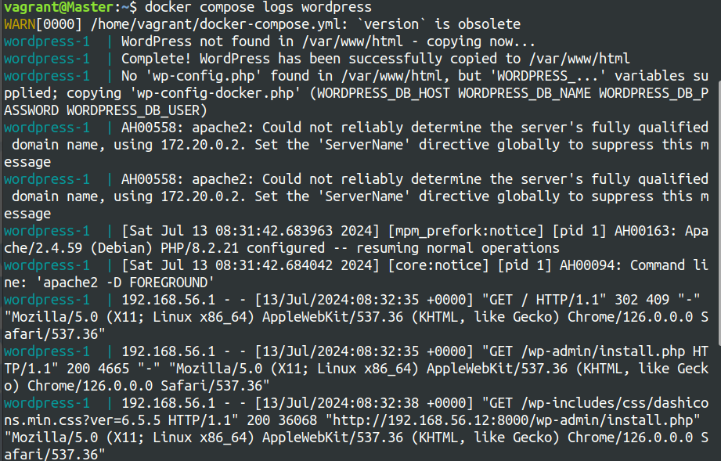

#### **6. Deploy the Application Using Docker Swarm**

Docker Swarm is a native clustering and orchestration tool for Docker.

* Initialize Docker Swarm.

docker swarm init

* Convert the Docker Compose file to a Docker Stack file, docker-stack.yml.

version: '3.3'

services:

db:

image: mysql:5.7

volumes:

- mysql_data:/var/lib/mysql

networks:

- wordpress_network

environment:

MYSQL_ROOT_PASSWORD: example

MYSQL_DATABASE: wordpress

MYSQL_USER: wordpress

MYSQL_PASSWORD: wordpress

deploy:

replicas: 1

wordpress:

image: wordpress:latest

volumes:

- wordpress_data:/var/www/html

networks:

- wordpress_network

ports:

- "8000:80"

environment:

WORDPRESS_DB_HOST: db:3306

WORDPRESS_DB_USER: wordpress

WORDPRESS_DB_PASSWORD: wordpress

WORDPRESS_DB_NAME: wordpress

deploy:

replicas: 1

volumes:

mysql_data:

wordpress_data:

networks:

wordpress_network:

* Deploy the stack using Docker Swarm.

docker stack deploy -c docker-stack.yml wordpress_stack

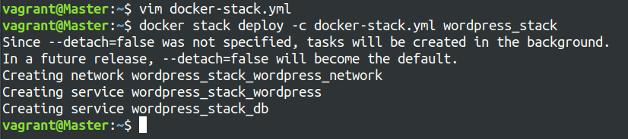

* Verify the stack is running.

docker stack services wordpress_stack

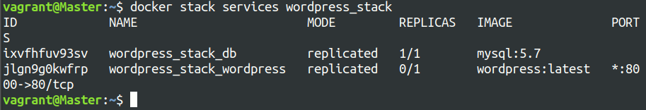

## **Project 02:**

## **Objectives:**

* Deploy an application across multiple Docker Swarm worker nodes.
* Place specific components on designated nodes.
* Monitor and troubleshoot using Docker logs.
* Modify and redeploy the application.

### **Project Outline:**

1. **Initialize Docker Swarm and Join Worker Nodes**
2. **Label Nodes for Specific Component Placement**
3. **Create a Docker Stack File**
4. **Deploy the Application**
5. **Monitor and Troubleshoot Using Docker Logs**
6. **Modify and Redeploy the Application**

### **Step-by-Step Guide**

#### **1. Initialize Docker Swarm and Join Worker Nodes**

On the manager node, initialize Docker Swarm:

docker swarm init --advertise-addr <MANAGER-IP>

Join the worker nodes to the swarm. On each worker node, run the command provided by the docker swarm init output:

docker swarm join --token <SWARM-TOKEN> <MANAGER-IP>:2377

Verify the nodes have joined:

docker node ls

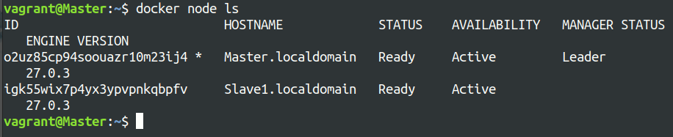

#### **2. Label Nodes for Specific Component Placement**

Label nodes to specify where certain components should run. For example, label a node for the database service:

docker node update --label-add db=true <NODE-ID>

Label another node for the application service:

docker node update --label-add app=true <NODE-ID>

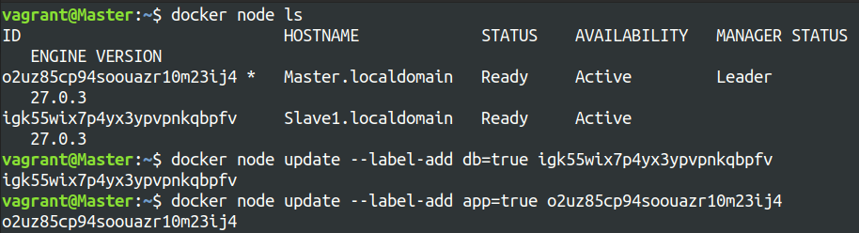

Verify the labels:

docker node inspect <NODE-ID>

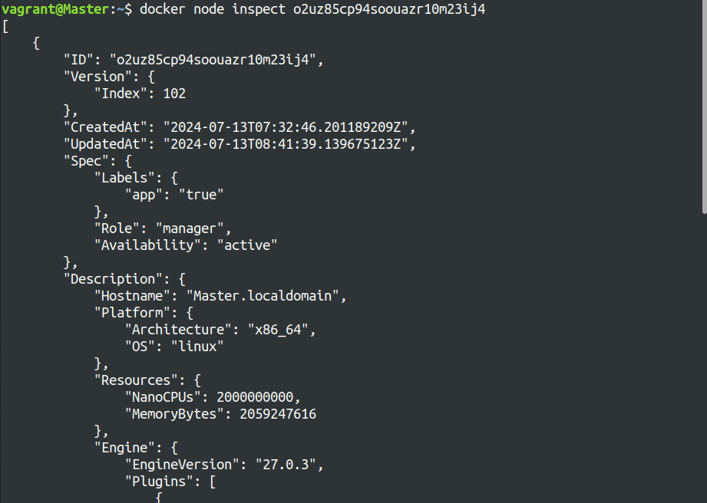

#### **3. Create a Docker Stack File**

Create a docker-stack.yml file to define the services and node placement constraints:

version: '3.8'

services:

db:

image: mysql:5.7

volumes:

- mysql_data:/var/lib/mysql

networks:

- app_network

environment:

MYSQL_ROOT_PASSWORD: example

MYSQL_DATABASE: appdb

MYSQL_USER: user

MYSQL_PASSWORD: password

deploy:

placement:

constraints:

- node.labels.db == true

app:

image: your-app-image

networks:

- app_network

ports:

- "8000:80"

environment:

DB_HOST: db

deploy:

replicas: 2

placement:

constraints:

- node.labels.app == true

volumes:

mysql_data:

networks:

app_network:

#### **4. Deploy the Application**

Deploy the stack using Docker Swarm:

docker stack deploy -c docker-stack.yml app_stack

docker stack services app_stack

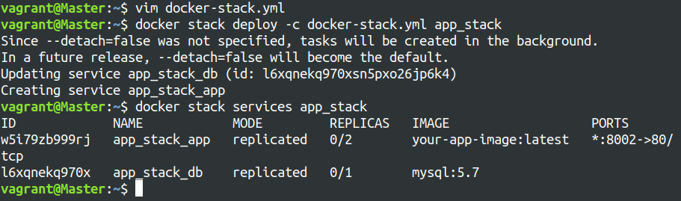

#### **5. Monitor and Troubleshoot Using Docker Logs**

Check the logs for the services:

docker service logs app_stack_db

docker service logs app_stack_app

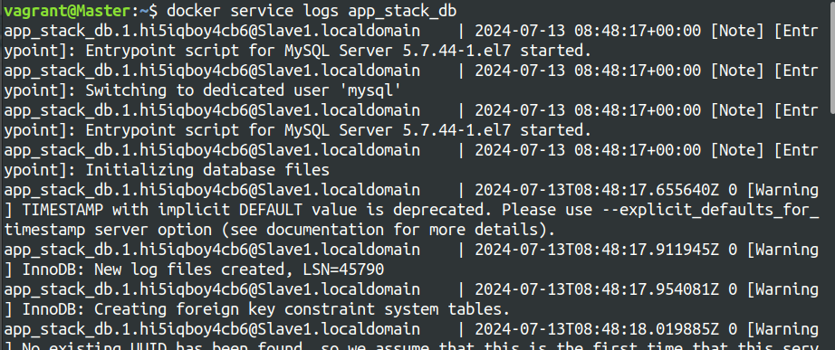

Follow the logs in real-time to monitor issues:

docker service logs -f app_stack_app

#### **6. Modify and Redeploy the Application**

Make modifications to the application or the stack file as needed. For example, change the number of replicas:

services:

app:

deploy:

replicas: 3

Update the stack with the new configuration:

docker stack deploy -c docker-stack.yml app_stack

Verify the changes:

docker stack services app_stack